Instructions
- This order form is to be submitted for any Sidekicks material requests
- Please complete all necessary sections
- You can submit requests at any time.
- Complete ALL information in each section

Sidekicks Welcome Packets:
If you are requesting Sidekicks Welcome Packets (youth and/or advisor), please complete the form below indicating which packets are needed

Youth Sidekicks Participation Kit:
If you are requesting Youth Sidekicks Participation Kits, please only do so for youth who have completed the full Sidekicks training and have submitted an evaluation. You are welcome to order participation kits at the same time as welcome packets, but please ensure they only go to youth who have completed the training. Please reference the Youth Sidekicks Participation Kit guidance on the DTPP resource page if you have any questions.

Shipping Information (where will we be sending these materials)
Attention:
Organization Name:
Address:

Notes:
- We appreciate your continued discretion of this free and limited resource. The Tobacco Prevention Services team will contact you if there is a concern about your request or if additional information is needed.
- Please order any Sidekicks packets AT LEAST 2 WEEKS IN ADVANCE of your scheduled training.
- Please contact the Tobacco Prevention Services team with any questions about Sidekicks at TobaccoPreventionServices@MaineHealth.org.

Name of DTPP Ordering:
Packet Type | # Requested | Planned Site/Training Date
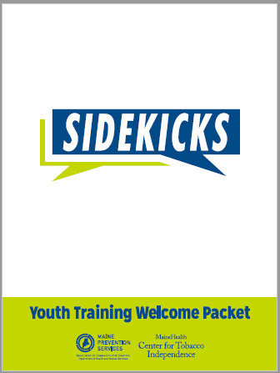  Youth Welcome Packet  (Commercial Tobacco) | # ___
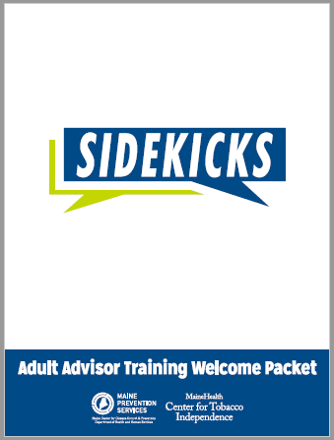  Original Advisor Welcome Packet | # ___
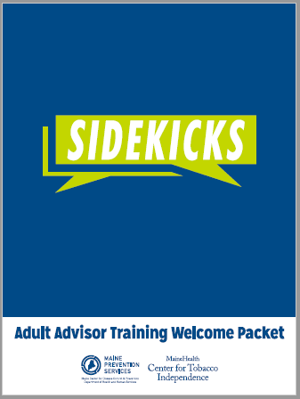  Tribal Advisor Welcome Packet | # ___
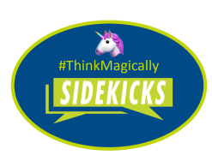  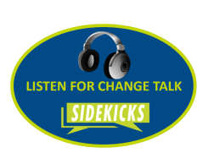  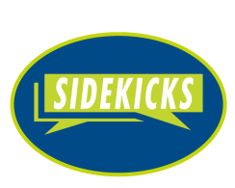  Stickers | # ___ Unicorn  # ____ Headphones  # ____ Logo Only | Stickers will be included Youth Welcome Packets on one sheet; this order should be for any supplemental or promotional efforts.
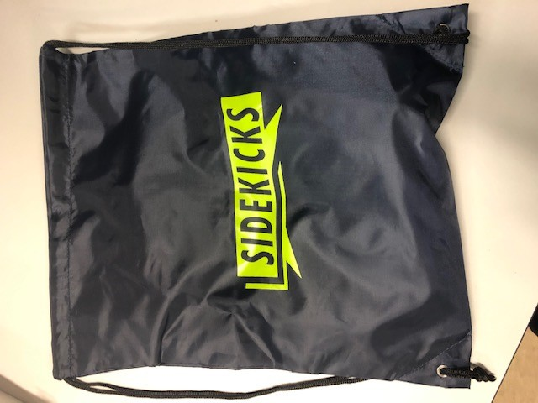  Youth Sidekicks Participation Kit | # ___ | Youth Sidekicks Participation Kits include: Drawstring bag, SK branded stress ball and pen, “I’m a Sidekick” pin, SK key take away postcard, MQL info card, Vape Free Maine info card

